 [Translated from German to English - www.onlinedoctranslator.com](https://www.onlinedoctranslator.com/en/?utm_source=onlinedoctranslator&utm_medium=docx&utm_campaign=attribution)

**1 Mechanics**

Pen station technical documentation

Oby Dr.-Ing. Paul Christiani GmbH & Co. KG **5**

**1.1 Functional description**

The pin station functional assembly is designed to insert clamping pins into workpieces. For this purpose, pins are stored in two magazines.­

The pin station consists of the workpiece holder, pin magazine and pin insert assemblies.

The following procedure is used for pins: an upright aluminum housing half is placed in the holder with the opening facing the magazine. The holder's pneumatic cylinder presses the workpiece against the front of the magazine. From the opposite side, the pin insert moves forward and, using the two ejectors, pushes two dowel pins halfway into the mounting holes of the workpiece halves. The holder cylinder then retracts and the pin insert extends completely. In doing so, it pushes the workpiece further back in the holder and the dowel pins are released from the magazine. The process is now complete and the workpiece with the dowel pins can be picked up from the holder.

The pen station can be mounted on two base plates as shown, or it can be mounted entirely on the large base plate and the control components on the small plate. Which configuration is more advantageous depends on the specific application.­

In both cases, the station can be mounted on an aluminum profile plate together with other functional modules.

Two 8-bit transfer connectors are available as transfer modules for connection to four digital PLC inputs and two digital PLC outputs.

The supply voltage of the functional module is 24 VDC and is provided via the 10-pin connecting cable.

The air supply is via a 4 mm air connection, the operating pressure is 4 bar.

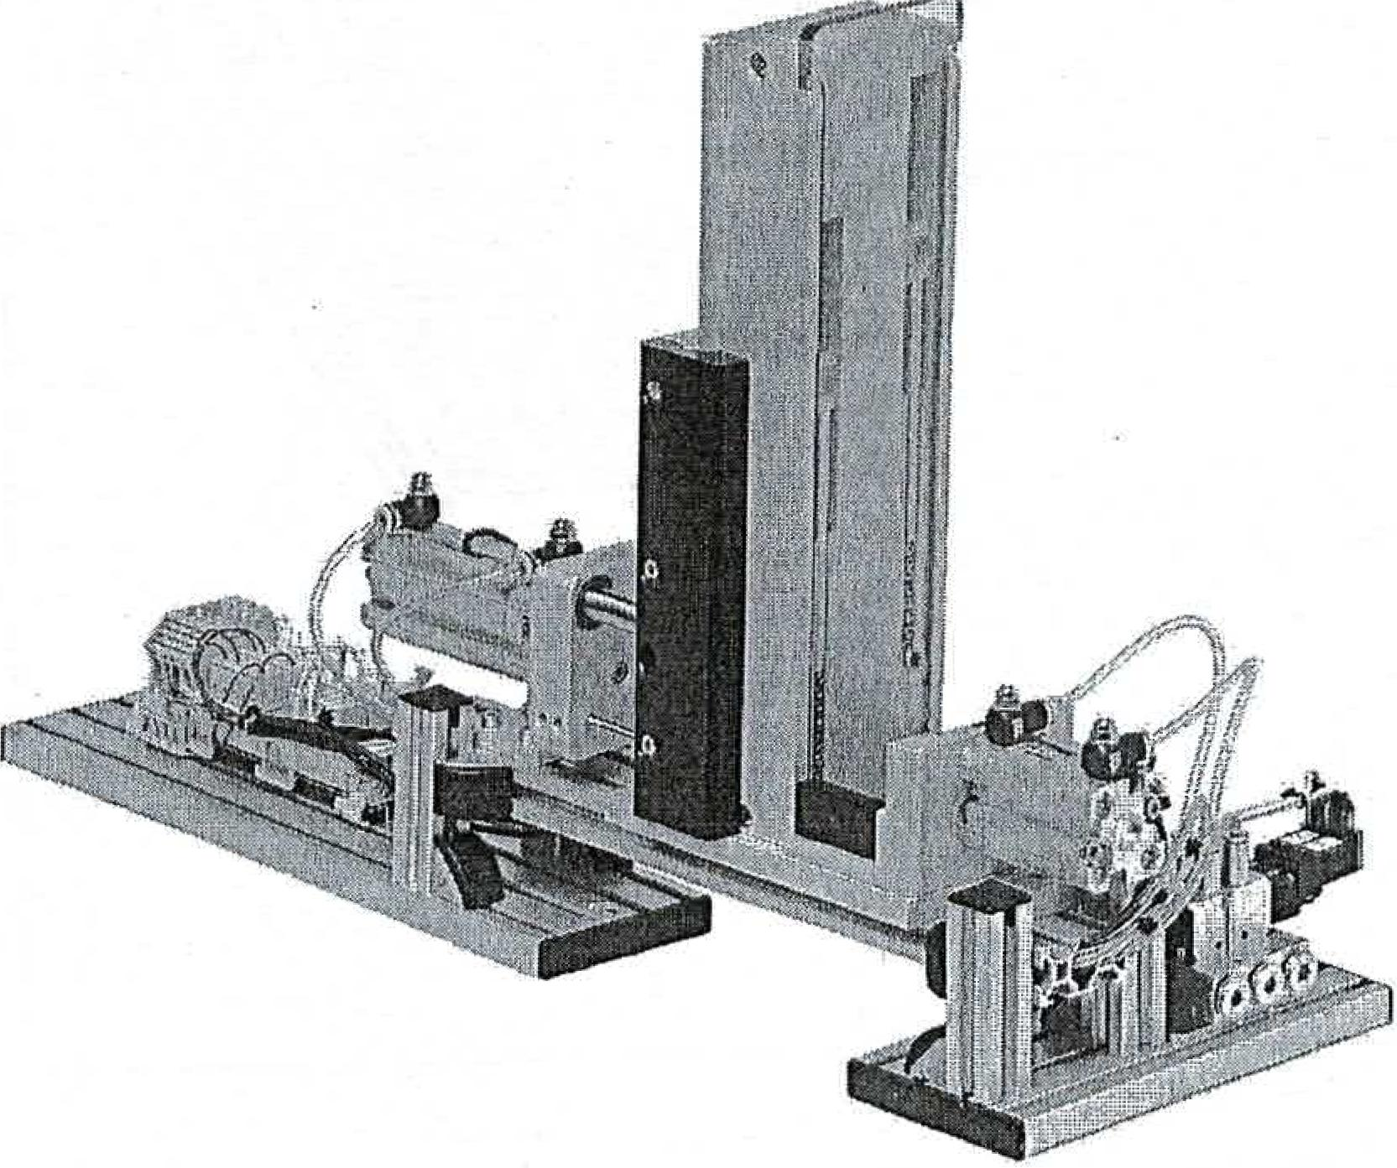

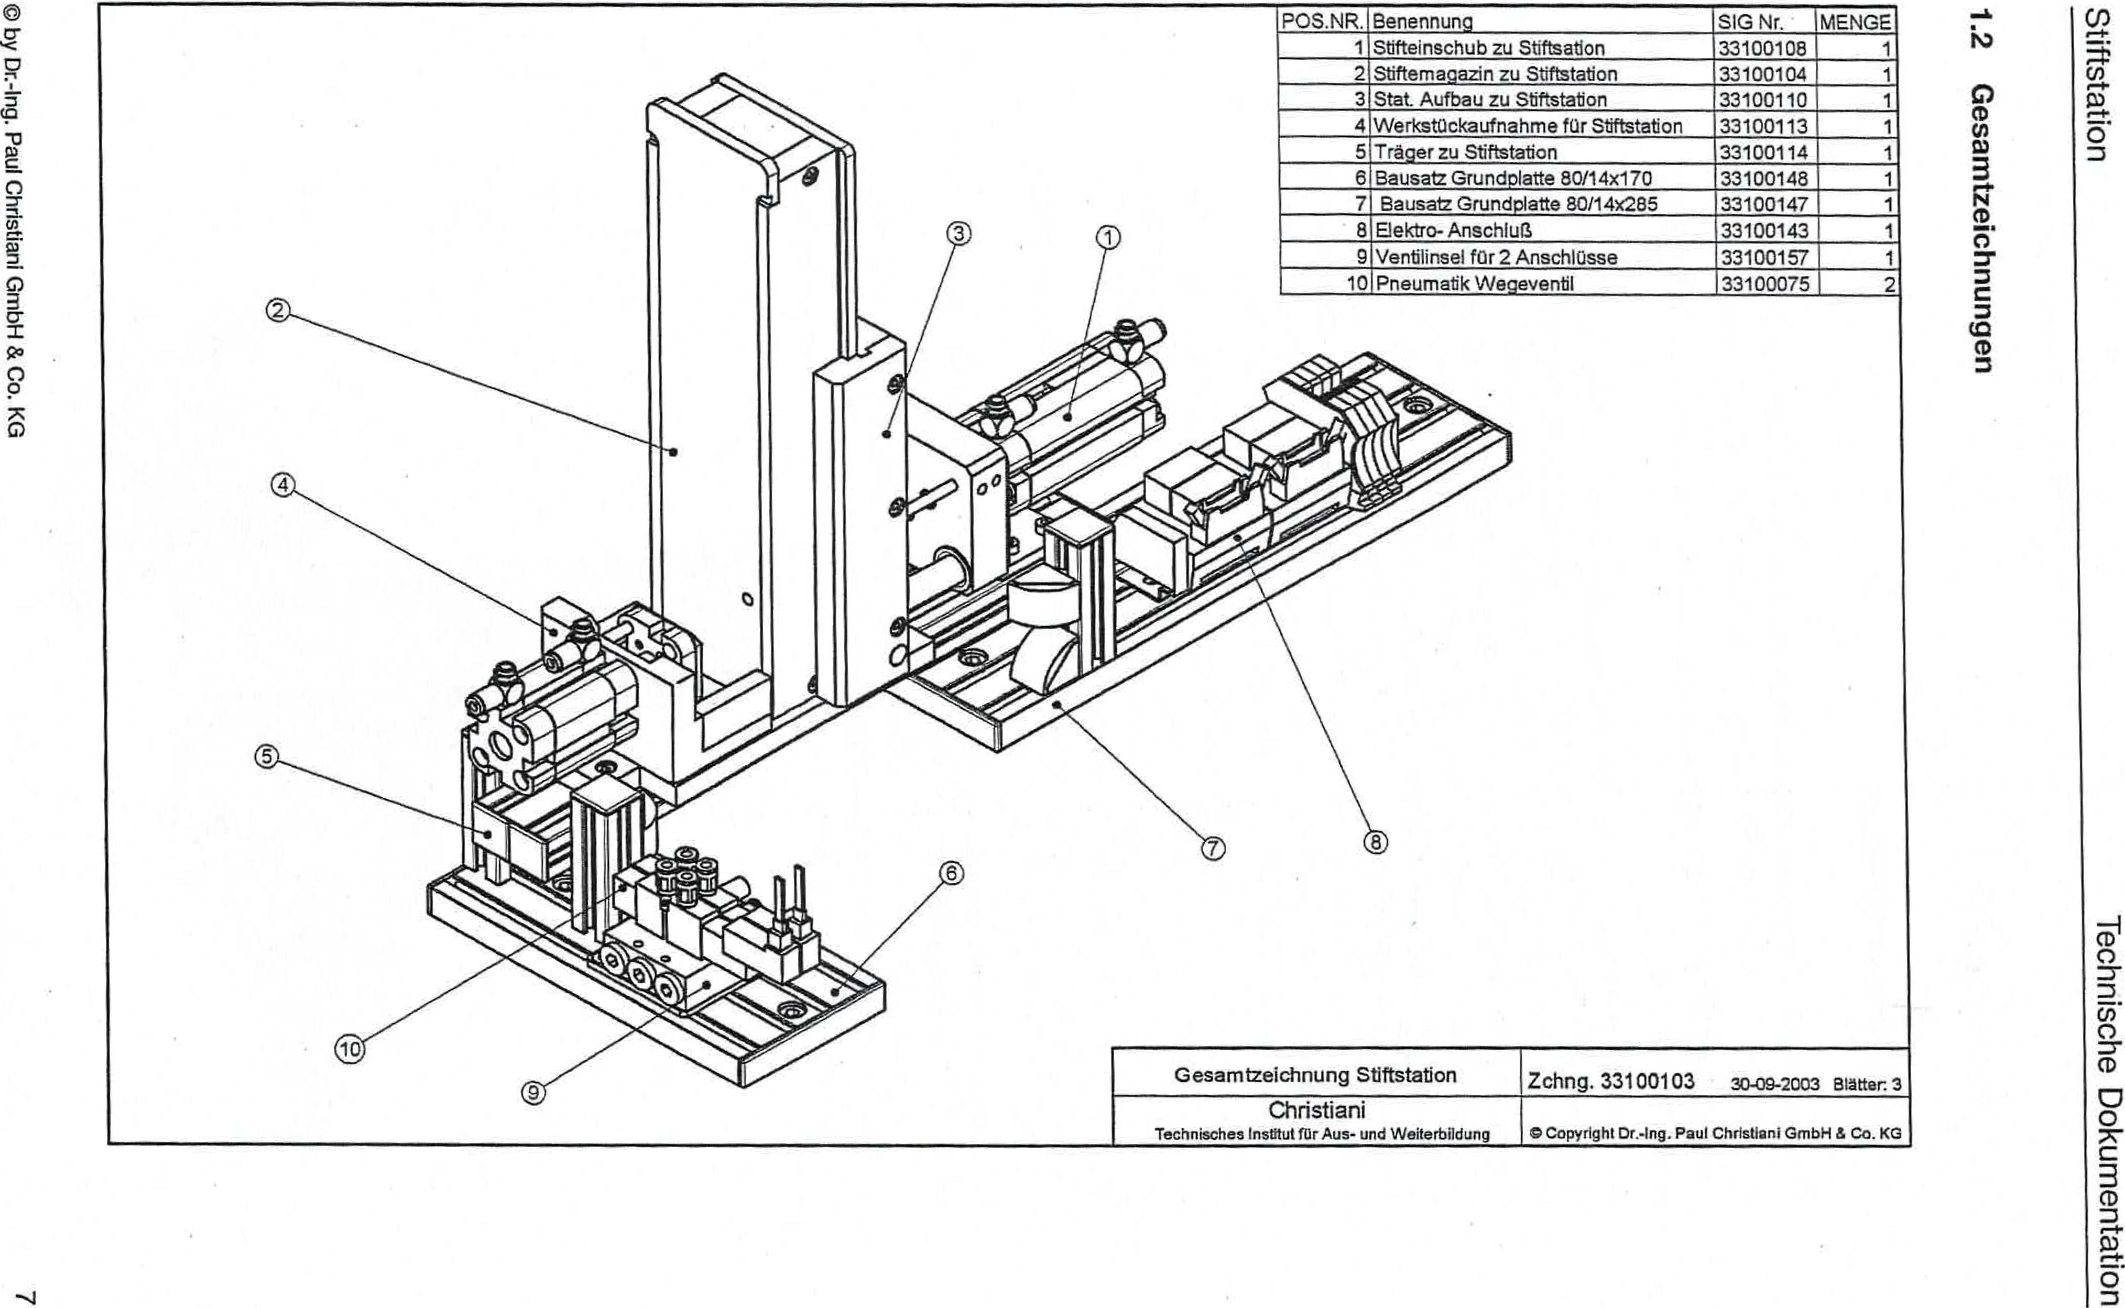

O by Dr.-Ing. Paul Christiani GmbH & Co. KG

**Ließunutiopziwesao**

uomuownloa eipspLpoi

33100114

1

5 carriers to pen station

33100148

6 Kit base plate 80/14x170

1

33100108 1

1 pen slot for pen station

[POS. NO.](http://POS.NR). Designation SIG No. QTY

Pen magazine for pen station 33100104

33100110 1

33100113 1

Workpiece holderforPen station

Stat. Structure for pen station

7 Base plate kit 80/14x285

8 Electrical connection

33100147 1

33100143 1

9 valve island for 2 connections

10 Pneumatic directional control valve

33100157

33100075 2

Overall drawing of pen station

Christiani

Technical Institute for Education and Training

Drawing 33100103 30-09-2003 Pages 3

Copyright Dr.-Ing. Paul Christiani GmbH & Co.KG

2

3